ACKNOWLEDGEMENT

We wish to express our sincere thanks and deep sense of gratitude to our project guide, Dr. Shruti Mishra, for her consistent encouragement and valuable guidance offered to us in a pleasant manner throughout the course of the project work. We also take this opportunity to thank all the faculty of the School for their support and their wisdom imparted to us throughout the course.

We thank our parents, family, and friends for bearing with us throughout the course of our project and for the opportunity they provided us in undergoing this course in such a prestigious institution.

CONTENTS:

Abstract
Introduction
Problem Statement & Objective
Proposed Model/Diagram
Result Analysis
Conclusion and Future Work
References

ABSTRACT:
In the present decade, India is planning a vital shift in the direction of start-up welcoming policies and a business-friendly or entrepreneur’s environment.

India is one of the fastest growing countries in terms of entrepreneurship. Entrepreneurship is an essential input for economic development, creating new markets or opportunities.

Currently, India is promoting entrepreneurship enthusiastically but it’s a huge challenge for government as well as large population of India to create employment via start-ups.

This report intention at analyzing investment pattern for Indian start-up ecosystem. In this project we have analysed on what factors does the start-up investment depends , what kinds of industries is preferred and we have analysed with time how the funding changes.

INTRODUCTION:
Title - Indian Startup Funding Trends
Broad Area – Analyzing investment pattern for Indian Startup ecosystem

India is one of the fastest-growing economies in the world.

In the past decade we have seen a large number of unicorn startups rise in the Indian startup ecosystem which has a global impact. Being so startup friendly the country has attracted numerous numbers of investors, both national and international. Therefore, a large amount of money is poured into the startup ecosystem.

Also due to government support, technology boon and rise of tier-2 and tier-3 cities has boosted the startup ecosystem. Tier II Cities like Varanasi, Kochi and Indore and others have also attracted a few startups.

Events like the launch of Startup India initiative.

Problem Statement & Objectives:
- How does the funding ecosystem change with respect to time?
- What kind of Industries is more preferred for startups?
- Does location also play a role in determining the growth of a startup?
- Who plays the main role in Indian startups ecosystem?
- What are the different types of funding for startups?
- Companies with most numbers of investors?
- Is Funding depends on the number of investors?

(Time Series Part)
  - Total investments over time(in USD)
    - Year Quarter No.
    - Year Month
  - Count of Investments over time
    - Year Quarter No.
    - Year Month
  - When funding was declared?
  - Is heavy count in seed funding also means heavy amount?
  - Total variation of funding amount per month in period of 2015-2017
  - How funding changed in 2015, 2016 & 2017 when it reached the peak monthly and quarterly wise?

Proposed Model/Diagram:
Tentative Techniques
- Data Cleaning – handling missing data, We filled the missing data using statistical methods like Mode of central tendency , Backward filling and forward filling.
- Multivariate Visualization
- Descriptive Analysis
- Time series Analysis

Methodologies used – Python, jupyter notebook, numpy, pandas, matplotlib, seaborn, squarify.

Result Analysis:
Does location also play a role in determining the growth of a startup?
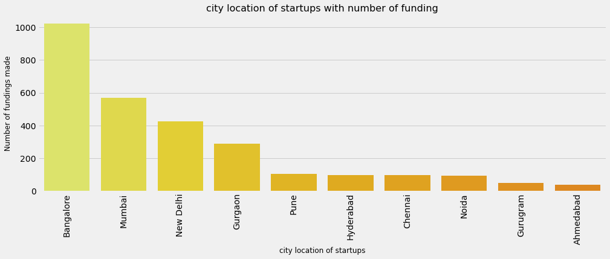

Who plays the main role in Indian startups ecosystem?

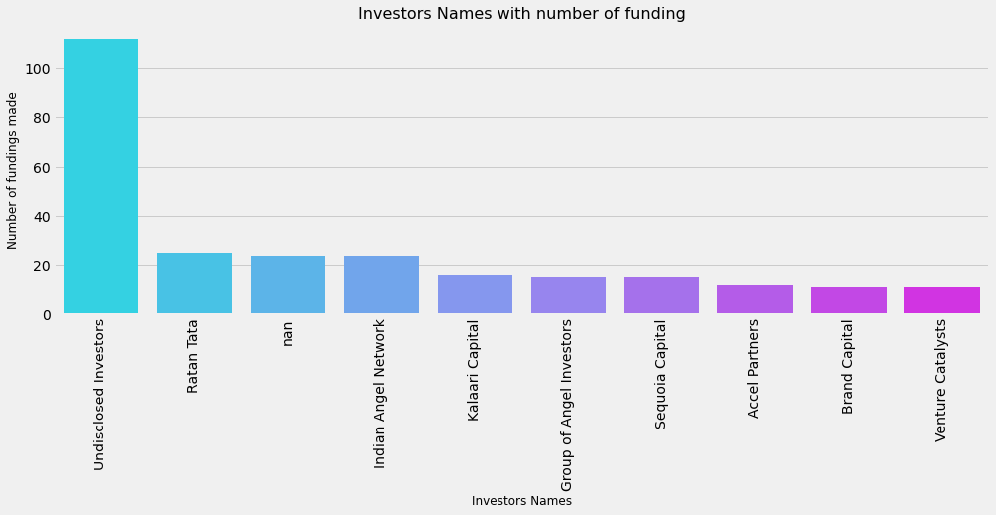
Ratan Tata, alone plays a very key role in Indian start-up ecosystem as relevant from the graph.

What are the different types of funding for startups?
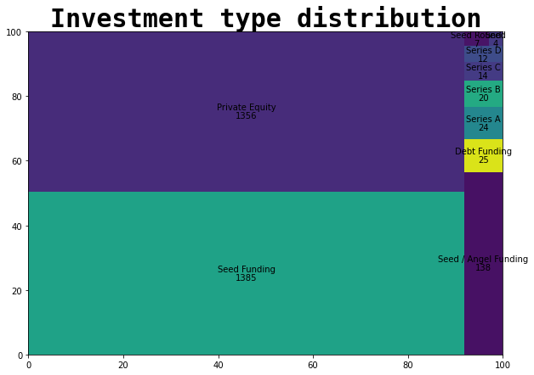
Both private equity and seed funding have funded almost equal number of start-ups.
Is heavy count in seed funding also means heavy amount?
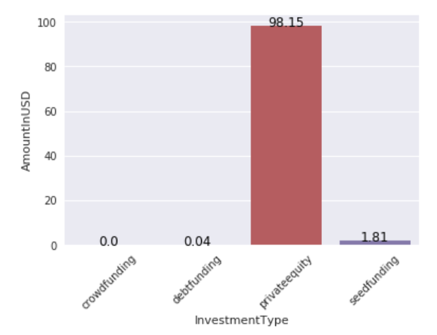
But the amount invested though seed funding doesn’t even stand in front of private ones.

Companies with most numbers of investors?
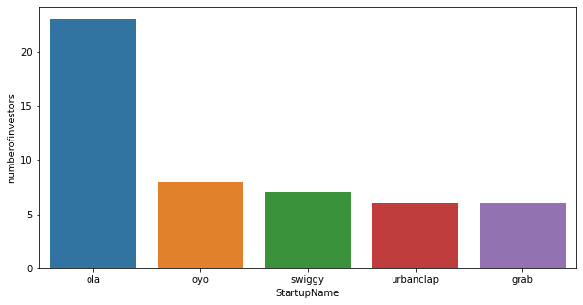
Big brands like Ola, Oyo, Swiggy have a lot of investors in them sharing the ownership.
Is Funding depends on the number of investors?
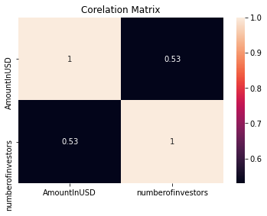
Here we can see that there is 50% relation between funding amount and number of investors.

TIME SERIES ANALYSIS:
How does the funding ecosystem change with respect to time?
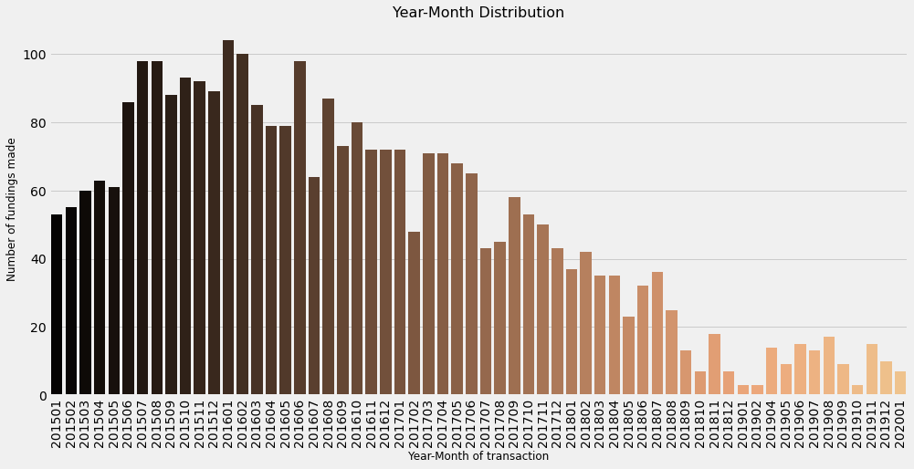

What is the amount (in USD) startups are getting year quarter and year monthly wise?
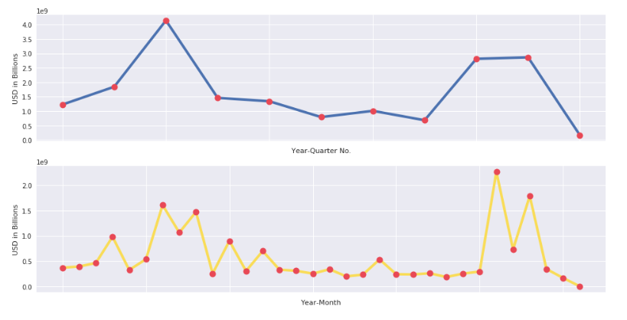

When funding was declared?
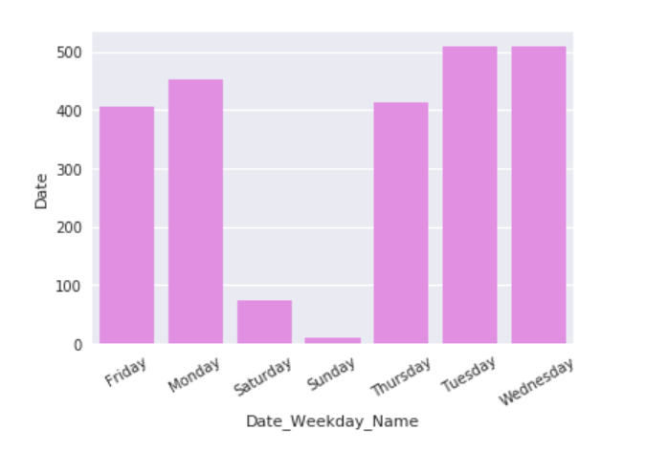

Total variation of funding amount per month in period of 2015-2017.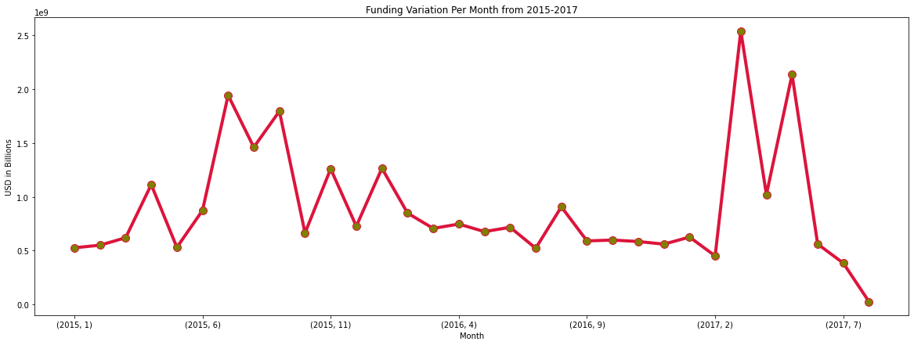

Predicting anything in this period was difficult

How funding changed in 2015, 2016 & 2017 when it reached the peak monthly and quarterly wise?

2015:
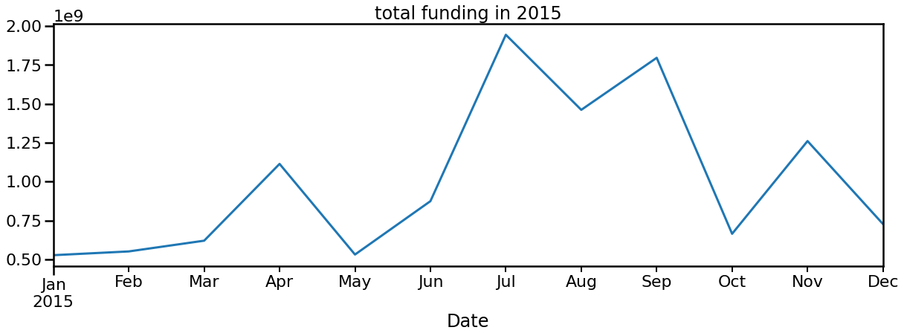
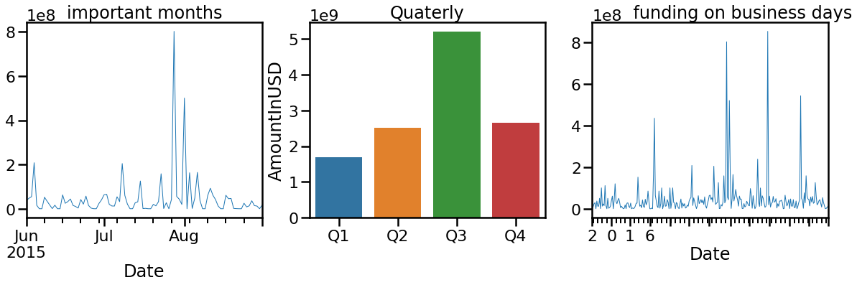
Below we can visualize that total funding reached to its peak between the months of june - july and Aug - Sep End week of july was most attracted to investments Quarter 3 was seen as the most funded quarter of 2015

2016:

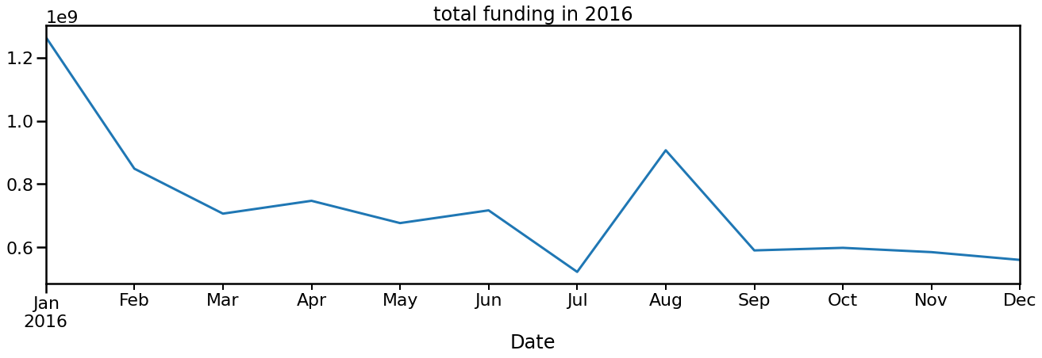
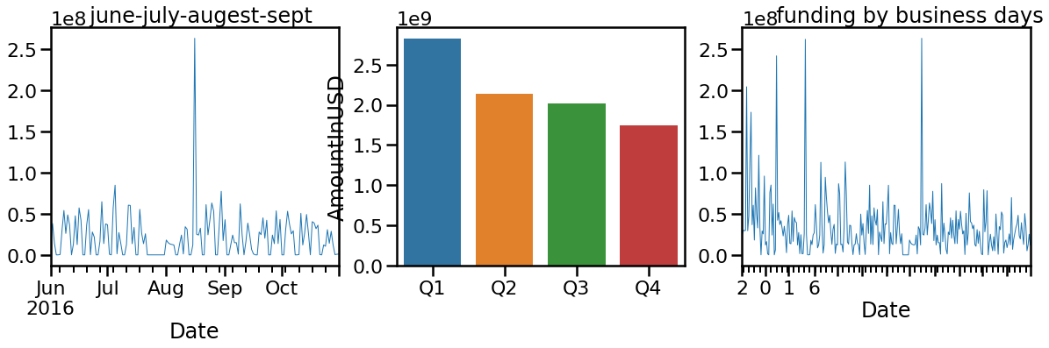

It seems to be january and augest was the most funding month in 2016. A sudden increase is witnessed in the month of july – August june seems to be the decline in funding may be due to goverment administration, further after september uniform low funding due to demonetization of indian currency early weeeks of augest seems to be the most funding time. An inverse relation among funding by Quarter.

2017:

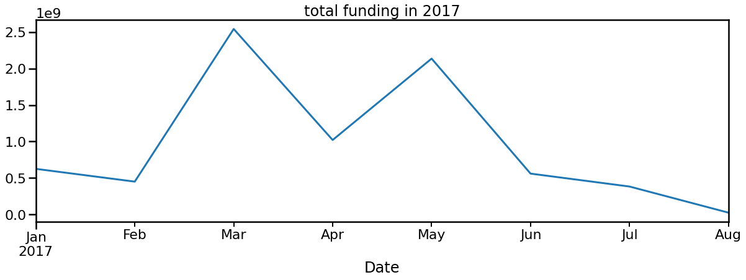
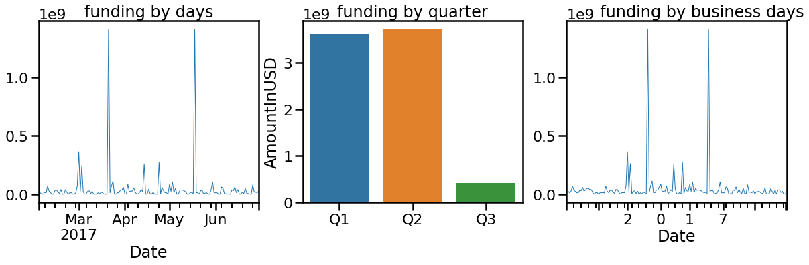
Month of March and second Week of May had seen peak funding scenarios Quarter 2 has most funding

CONCLUSION & FUTURE WORK:

Technology-based start-ups which provide their services to the everyday consumer are very probable to get a lot of funding. A large number of start-ups based in metropolitan cities are funded, which may be due to the fact of easy accessibility to all resources.

Most of the fundings are either of Private Equity and Seed Funding type.

Ratan Tata, Indian Angel Network, and Kalaari Capital are some of the top investors in the Indian startup ecosystem.

There was 50% relation between funded amount and number of investors per startup.

2016 had highest amount of investments.Over the year, during some periods the funding gets increased too much like 3rd quarter in 2015, September in 2016, March to May in 2017. The period is highly unpredictable.

Future work- In future we will apply machine learning algorithms for prediction analysis of fundings of startups.

REFERENCES:
  - https://towardsdatascience.com/
  - https://www.kaggle.com/
  - https://www.analyticsvidhya.com/blog/2022/01/10-best-data-science-websites-to-find-datasets-for-your-next-ds-project/
  - https://www.irjet.net/archives/V5/i11/IRJET-V5I11297.pdf
  - https://www.coursera.org/in
  - https://www.statisticssolutions.com/free-resources/directory-of-statistical-analyses/time-series-analysis/
  - https://en.wikipedia.org/wiki/List_of_unicorn_startup_companies
  - https://en.wikipedia.org/wiki/Timeline_of_Indian_startup_ecosystem
  - https://www.investopedia.com/ask/answers/032515/what-does-it-mean-if-correlation-coefficient-positive-negative-or-zero.asp
  - https://www.investopedia.com/terms/t/timeseries.asp
  - https://www.machinelearningplus.com/time-series/time-series-analysis-python/
  - https://www.startupindia.gov.in/content/sih/en/international/go-to-market-guide/indian-startup-ecosystem.html
  - https://yourstory.com/2022/02/coming-age-indian-startup-ecosystem/amp

